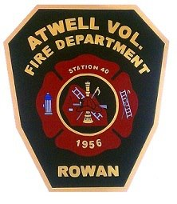

**Atwell Township Vol. Fire Department**

Station 40 Station 50

135 Concordia Church Rd 8480 Unity Church Rd

China Grove, N.C. 28023 Kannapolis, N.C. 28081

(704) 855-3240 (704)934-2375

BOARD MEMBER APPLICATION:

Name: _____________________________________

Adress: ______________________________________

Phone Number: ______________________

Email Adress: ________________________

Reason for joining the Board of Directors: ______________________________________________________________________________________________________________________________________________________________________________________________________________________________________________________________________________________________________________________________________________________________________________________________________________________________________________________________________________________________________________________________________________________________________________________________________________________________________________________________________________________________________________________________

Signature: ___________________________

Date of Completion: _______________